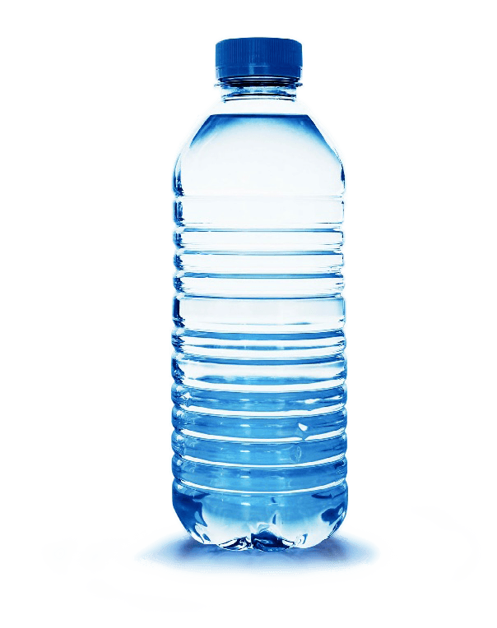

PRESS UPS

SIT UPS

MOUNTAIN CLIMBERS

JUMPING JACKS

PLANK

SQUATS

LUNGES

**LEVEL 1: 30 SECONDS**

**LEVEL 2: 45 SECONDS**

**LEVEL 3: 1 MINUTE**

**EXTENSION TASKS:**

**COMPLETE WITH PEOPLE WITHIN YOUR HOUSEHOLD**

**COME UP WITH YOUR OWN EXERCISES**

Write out the exercises below and then spin the bottle. When the bottle lid stops on an exercise, complete activity.

FITNESS ACTIVITY

SPIN THE BOTTLE!