Year 6 Summer Graphics Project – Nature Money Box!
Instructions
What is a net?
The net of a 3D shape is what it looks like if it is opened out flat. A net can be folded up to make a 3D shape.
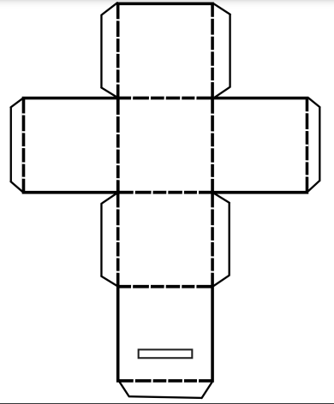

- Cut out your net using the block lines.
- To cut out the space for the money to fit into your box, cut into the middle of the rectangle and then work your way around the edges to create enough space for those pennies!
- Carefully fold your net along each dashed line and you should begin to see a box shape!
- Apply glue to each tab to fix the net into its box shape.
- Cut out any summer images that you would like to decorate your summer money box with such as bees and butterflies!
- Glue the images into place to create a stylish money box.
Finished using your net? Remember to recycle the paper rather than throw it away!

