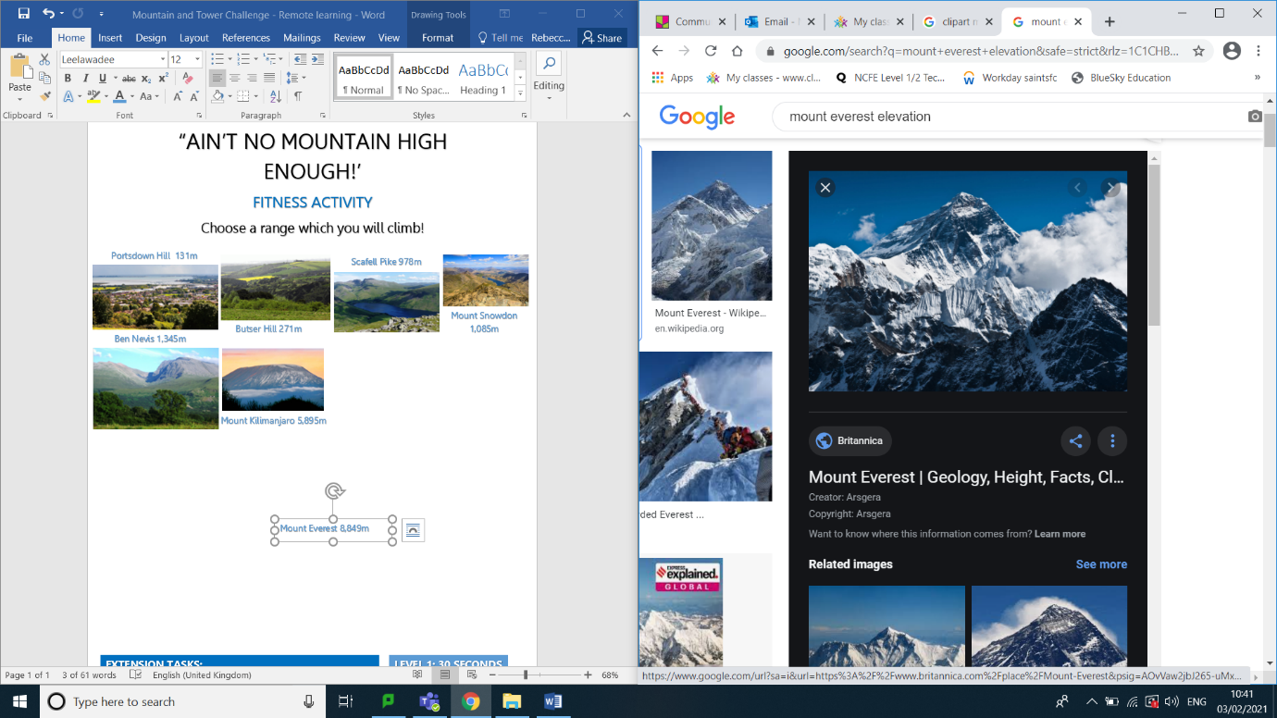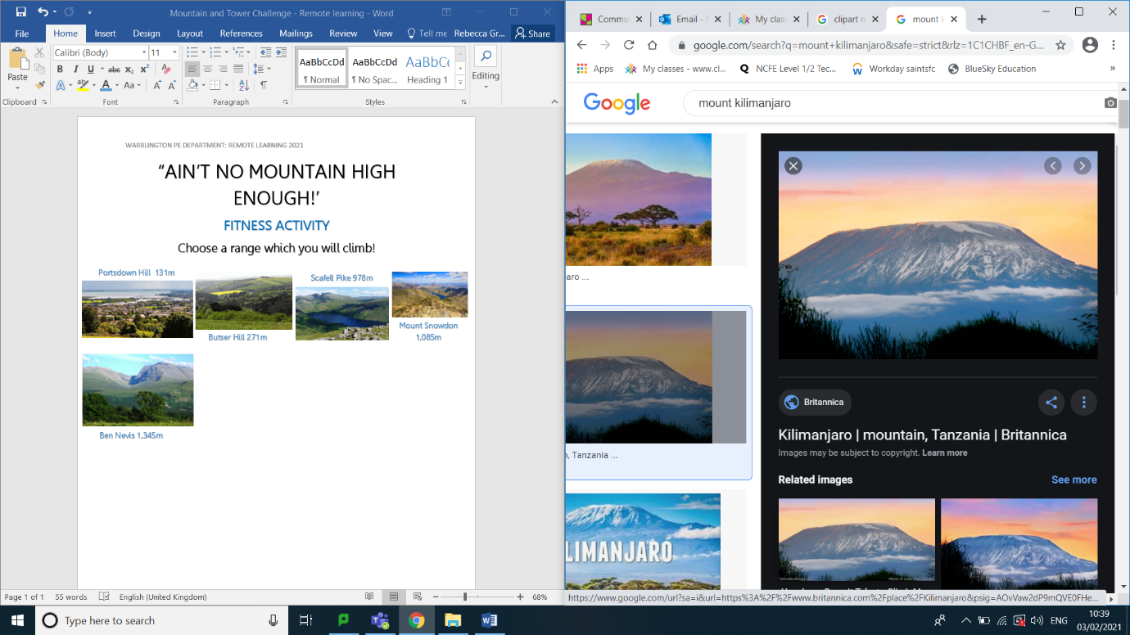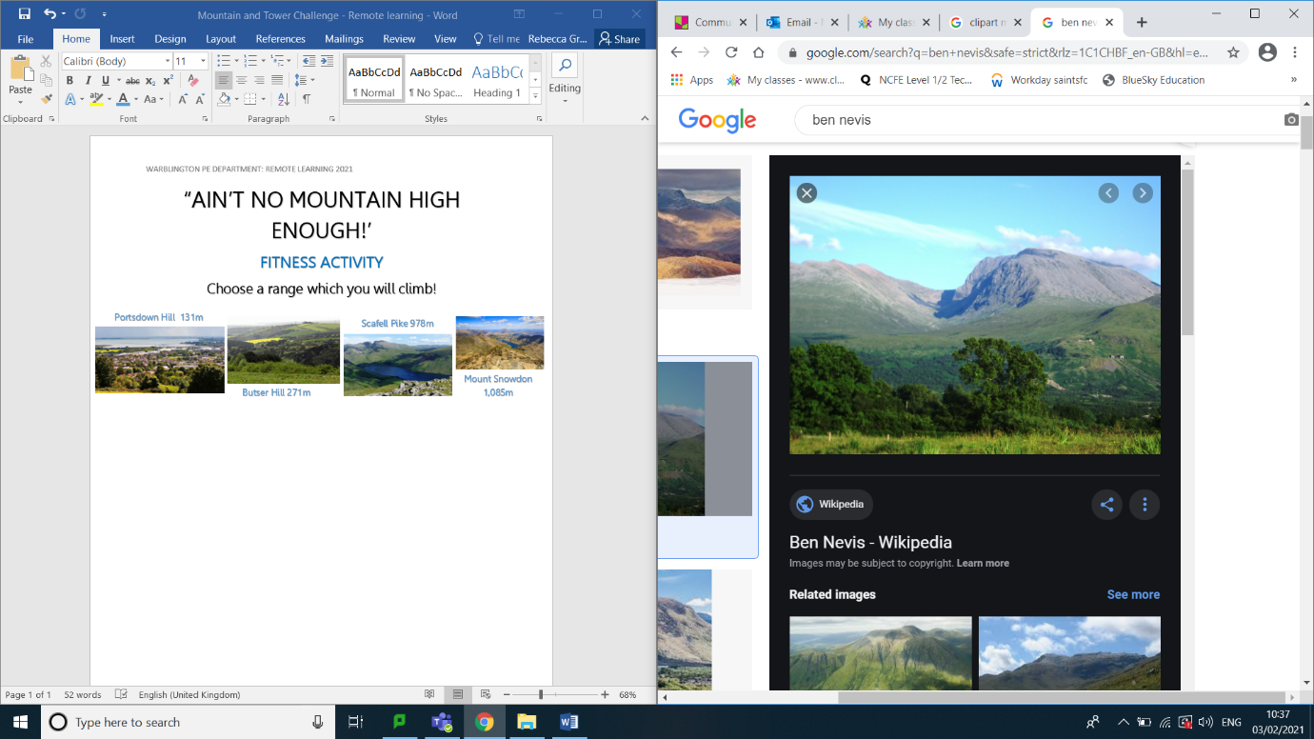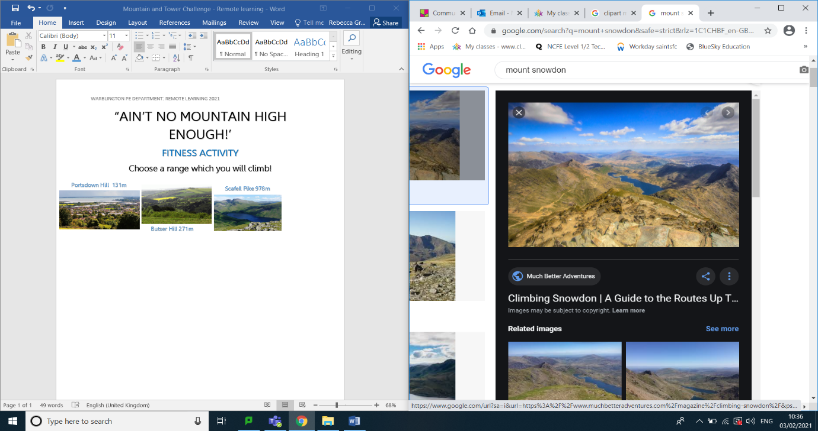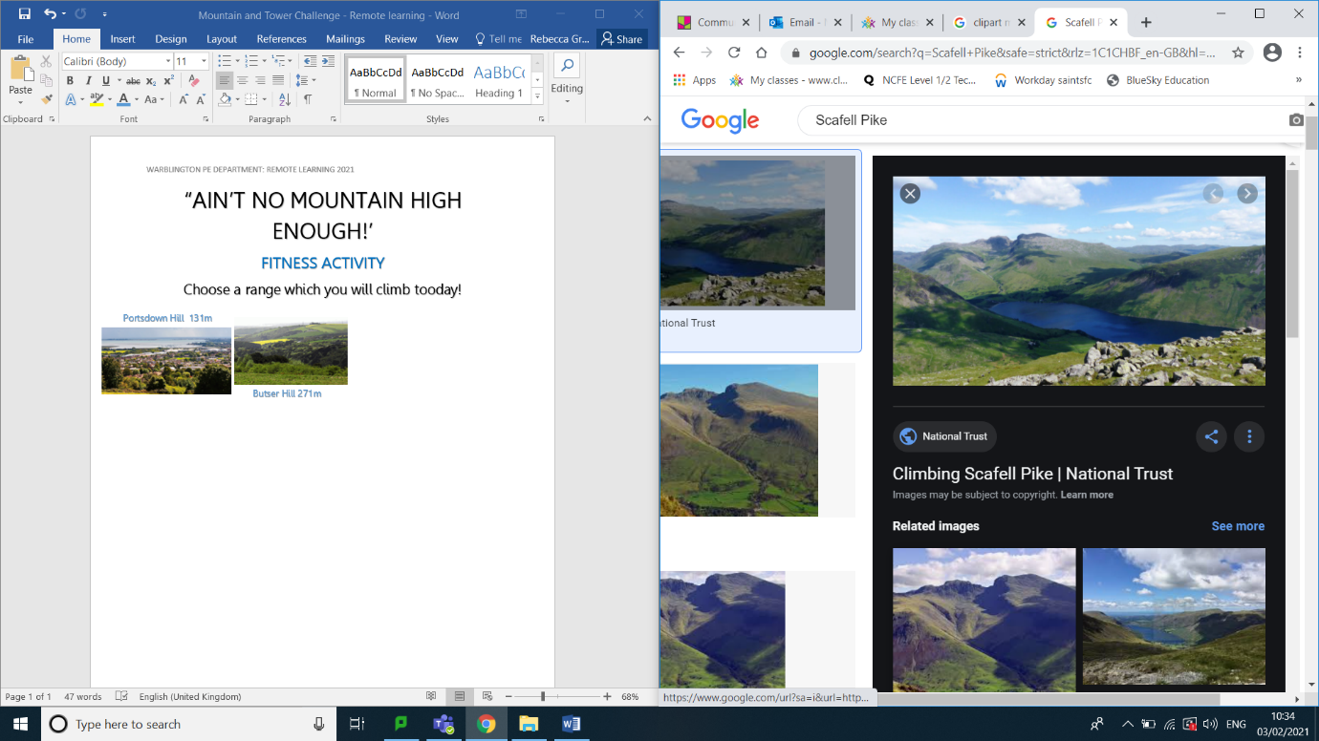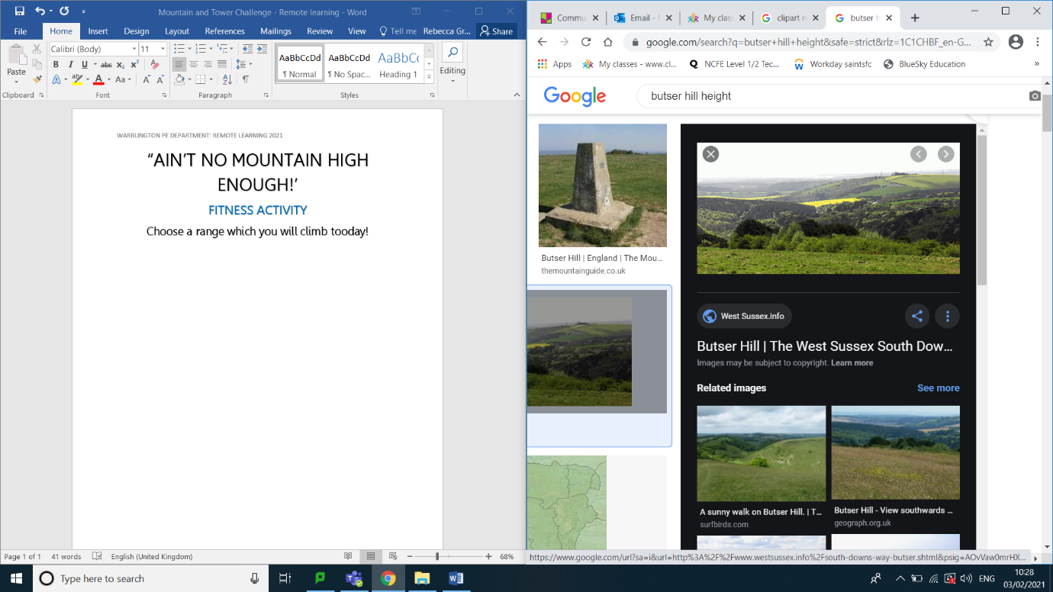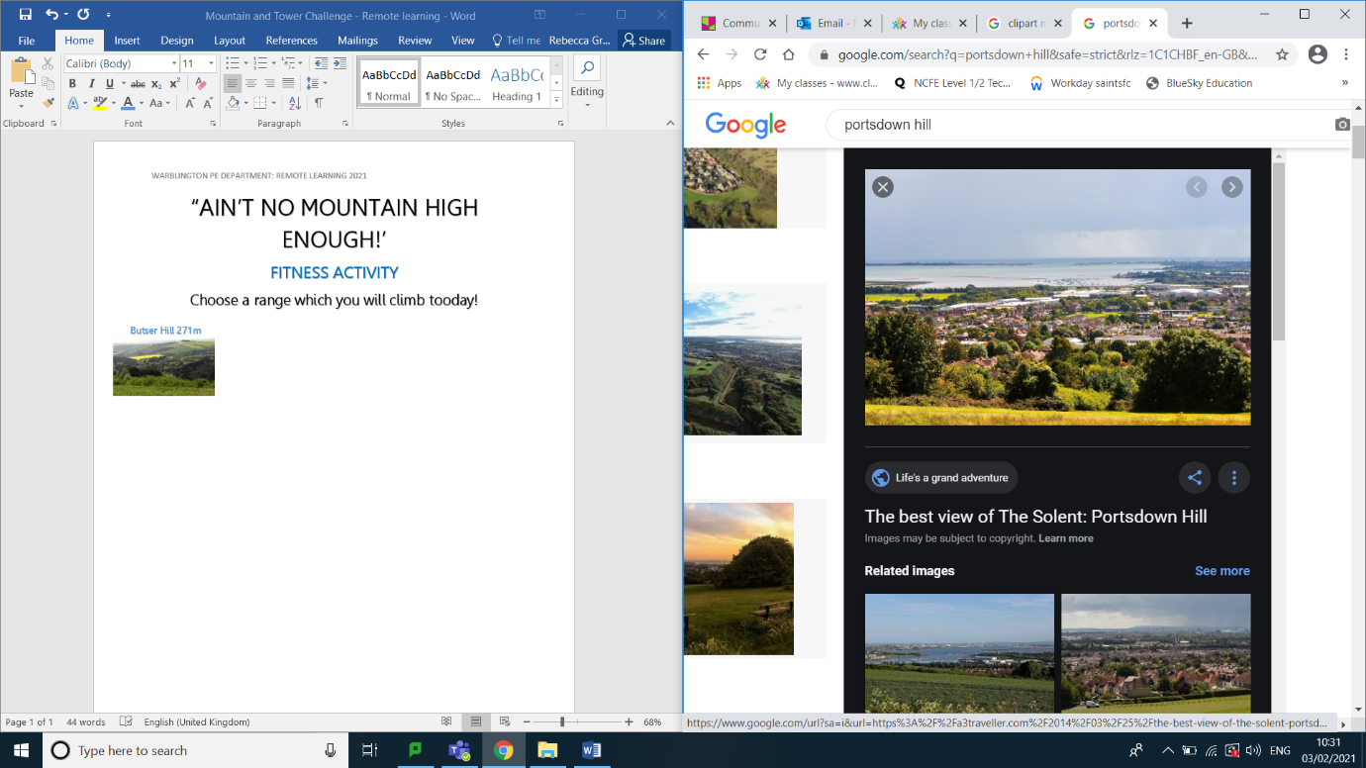

Mount Everest 8,849m

Mount Kilimanjaro 5,895m

Ben Nevis 1,345m

Mount Snowdon 1,085m

Scafell Pike 978m

Butser Hill 271m

Portsdown Hill 131m

Choose a range which you will climb by completing mountain climbers for every metre of the mountain!

SAFETY: Maximum of 20 mountain climbers before rest. If you climb a large mountain, we do not expect this to be completed today. Please let your teacher know which one you are climbing and if you were successful!

FITNESS ACTIVITY

“AIN’T NO MOUNTAIN HIGH ENOUGH!”

**LEVEL 1: 15 SECONDS**

**LEVEL 2: 20 SECONDS**

**LEVEL 3: 30 SECONDS**

**EXTENSION TASKS:**

**COMPLETE WITH PEOPLE WITHIN YOUR HOUSEHOLD**

**COME UP WITH YOUR OWN EXERCISES**