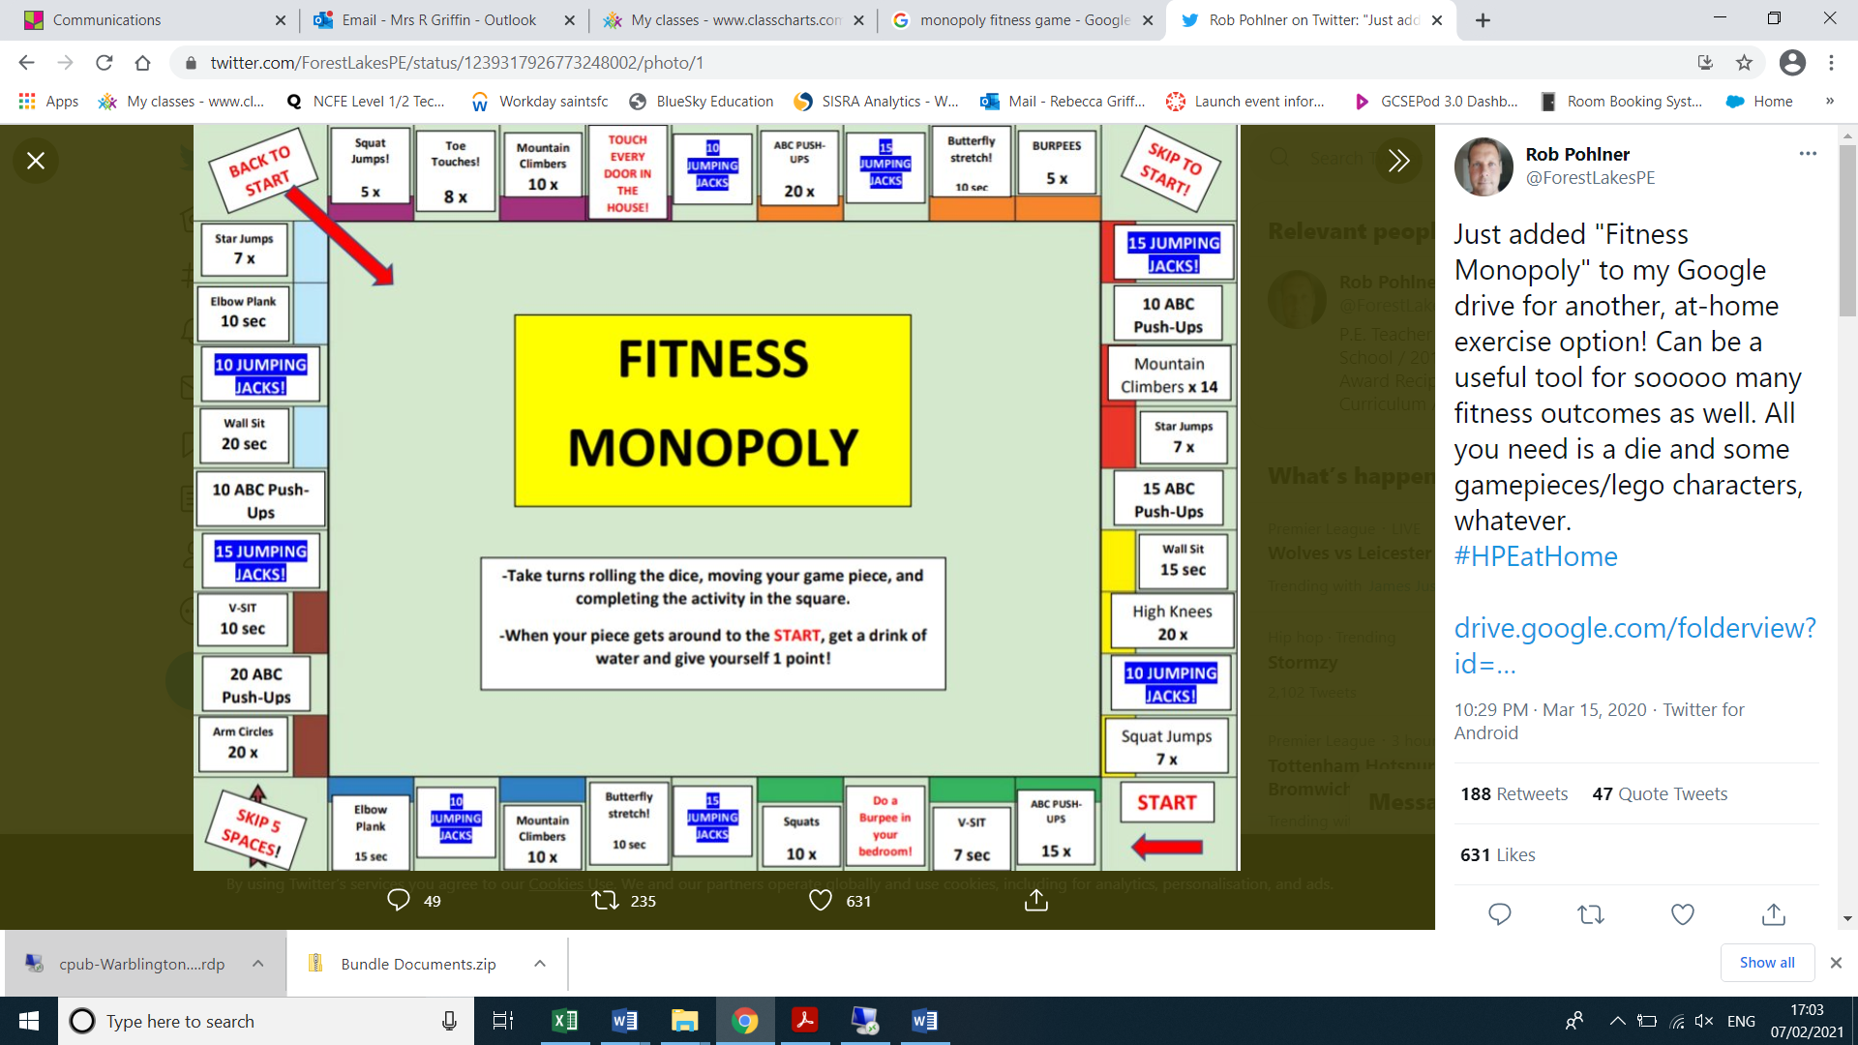

**EXTENSION**

**COMPLETE WITH PEOPLE WITHIN YOUR HOUSEHOLD OR VIRTUALLY WITH FRIENDS OR DESIGN YOUR OWN FITNESS MONOPOLY BOARD CHOSING YOUR OWN ACTIVITIES**

Complete the Fitness Monopoly Challenge and the exercises outlined!

Complete 3 laps of the board with 2 minute rest in between each activity.